**Olympic Games Database Management Project**

**Problem Statement**

In this project, I have designed a database management system to store information about the Olympic games.

The database will contain details of the Olympic teams of each country, participating athletes and their support staff, sporting venues and spectating audiences' details. It also provides categorization of tickets and events, details of accommodation and transport for participants, ranking based on sport/country, match fixtures, sponsors, and other recreational facilities for both participants and audience.

This database was created with the objective of assisting the International Olympic Committee in successfully organizing the Olympic games. It aims to provide an efficient and secure environment for the organizing committee to store, access, manage and analyze the essential information for the smooth conduct of the Olympics.

**ER Model Assumptions**

1. Only two players can play in a match.
2. Each player can only have one coach.
3. Each vehicle can only operate for one accommodation.
4. Each match can only have one official.
5. Each event can only take place in one stadium.

**ER Diagram**

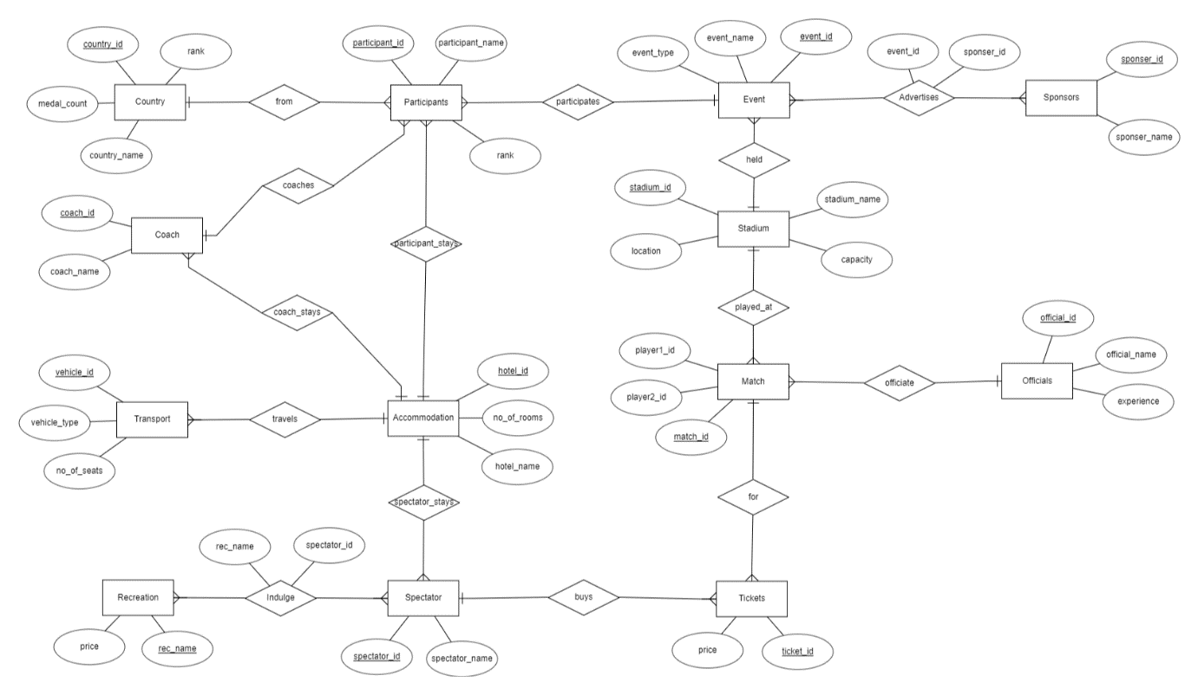

**Relational Schema:**

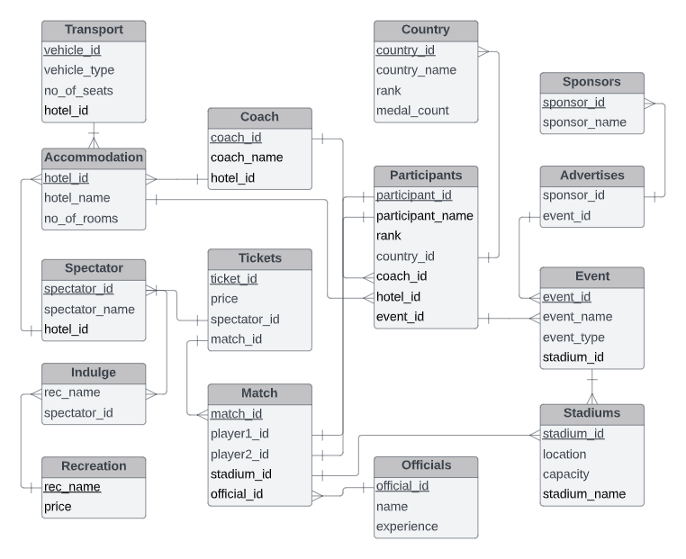

**Tables**

**Transport**

|  |  |  |
| --- | --- | --- |
| **Attribute** | **Data Type** | **Constraints** |
| vehicle_id | NUMBER | PRIMARY KEY |
| vehicle_type | VARCHAR(30) |  |
| no_of_seats | NUMBER |  |
| hotel_id | NUMBER | FOREIGN KEY |

**Country**

|  |  |  |
| --- | --- | --- |
| **Attribute** | **Data Type** | **Constraints** |
| country_id | NUMBER | PRIMARY KEY |
| country_name | VARCHAR(30) |  |
| rank | NUMBER |  |
| medal_count | NUMBER |  |

**Sponsors**

|  |  |  |
| --- | --- | --- |
| **Attribute** | **Data Type** | **Constraints** |
| sponsor_id | NUMBER | PRIMARY KEY |
| sponsor_name | VARCHAR(30) |  |

**Coach**

|  |  |  |
| --- | --- | --- |
| **Attribute** | **Data Type** | **Constraints** |
| coach_id | NUMBER | PRIMARY KEY |
| coach_name | VARCHAR(30) |  |
| hotel_id | NUMBER | FOREIGN KEY |

**Accommodation**

|  |  |  |
| --- | --- | --- |
| **Attribute** | **Data Type** | **Constraints** |
| hotel_id | NUMBER | PRIMARY KEY |
| hotel_name | VARCHAR(30) |  |
| no_of_rooms | NUMBER |  |

**Participants**

|  |  |  |
| --- | --- | --- |
| **Attribute** | **Data Type** | **Constraints** |
| participant_id | NUMBER | PRIMARY KEY |
| participant_name | VARCHAR(30) |  |
| rank | NUMBER |  |
| country_id | NUMBER | FOREIGN KEY |
| coach_id | NUMBER | FOREIGN KEY |
| hotel_id | NUMBER | FOREIGN KEY |
| event_id | NUMBER | FOREIGN KEY |

**Advertises**

|  |  |  |
| --- | --- | --- |
| **Attribute** | **Data Type** | **Constraints** |
| sponsor_id | NUMBER | FOREIGN KEY |
| event_id | NUMBER | FOREIGN KEY |

**Spectator**

|  |  |  |
| --- | --- | --- |
| **Attribute** | **Data Type** | **Constraints** |
| spectator_id | NUMBER | PRIMARY KEY |
| spectator_name | VARCHAR(30) |  |
| hotel_id | NUMBER | FOREIGN KEY |

**Tickets**

|  |  |  |
| --- | --- | --- |
| **Attribute** | **Data Type** | **Constraints** |
| ticket_id | NUMBER | PRIMARY KEY |
| price | FLOAT |  |
| spectator_id | NUMBER | FOREIGN KEY |
| match_id | NUMBER | FOREIGN KEY |

**Event**

|  |  |  |
| --- | --- | --- |
| **Attribute** | **Data Type** | **Constraints** |
| event_id | NUMBER | PRIMARY KEY |
| event_name | VARCHAR(30) |  |
| event_type | VARCHAR(30) |  |
| stadium_id | NUMBER | FOREIGN KEY |

**Indulge**

|  |  |  |
| --- | --- | --- |
| **Attribute** | **Data Type** | **Constraints** |
| rec_name | VARCHAR(30) | FOREIGN KEY |
| spectator_id | NUMBER | FOREIGN KEY |

**Recreation**

|  |  |  |
| --- | --- | --- |
| **Attribute** | **Data Type** | **Constraints** |
| rec_name | VARCHAR(30) | PRIMARY KEY, |
| price | FLOAT |  |

**Match**

|  |  |  |
| --- | --- | --- |
| **Attribute** | **Data Type** | **Constraints** |
| match_id | NUMBER | PRIMARY KEY |
| player1_id | NUMBER | FOREIGN KEY |
| player2_id | NUMBER | FOREIGN KEY |
| stadium_id | NUMBER | FOREIGN KEY |
| official_id | NUMBER | FOREIGN KEY |

**Officials**

|  |  |  |
| --- | --- | --- |
| **Attribute** | **Data Type** | **Constraints** |
| official_id | NUMBER | PRIMARY KEY |
| name | VARCHAR(30) |  |
| experience | NUMBER |  |

**Stadiums**

|  |  |  |
| --- | --- | --- |
| **Attribute** | **Data Type** | **Constraints** |
| stadium_id | NUMBER | PRIMARY KEY |
| location | VARCHAR(30) |  |
| capacity | NUMBER |  |
| stadium_name | VARCHAR(30) |  |

**Functional Dependency and Primary Key:**

**Sponsors:**

sponsor_id -> {sponsor_id, sponsor_name}

Since all the fields depend on sponsor_id, (sponsor_id)+ -> R

Hence, sponsor_id is Primary Key of Sponsors table

**Accomodation:**

hotel_id -> {hotel_id, hotel_name, no_of_rooms}

Since all the fields depend on hotel_id, (hotel_id)+ -> R

Hence, hotel_id is Primary Key of Accomodation table

**Transport:**

vehicle_id -> {vehicle_id, vehicle_type, no_of_seats, hotel_id}

Since all the fields depend on vehicle_id, (vehicle_id)+ -> R

Hence, vehicle_id is Primary Key of Transport table

**Coach:**

coach_id -> {coach_id, coach_name, hotel_id}

Since all the fields depend on coach_id, (coach_id)+ -> R

Hence, coach_id is Primary Key of Coach table

**Stadiums:**

stadium_id -> {stadium_id, location, capacity, stadium_name}

Since all the fields depend on stadium_id, (stadium_id)+ -> R

Hence, stadium_id is Primary Key of Stadiums table

**Country:**

country_id -> {country_id, country_name, rank, medal_count}

Since all the fields depend on stadium_id, (country_id)+ -> R

Hence, country_id is Primary Key of Country table

**Officials:**

official_id -> {official_id, name, experience}

Since all the fields depend on official_id, (official_id)+ -> R

Hence, official_id is Primary Key of Officials table

**Spectators:**

spectator_id -> {spectator_id, spectator_name, hotel_id}

Since all the fields depend on spectator_id, (spectator_id)+ -> R

Hence, spectator_id is Primary Key of Spectators table

**Recreation:**

rec_name -> {rec_name, price}

Since all the fields depend on rec_name, (rec_name)+ -> R

Hence, rec_name is Primary Key of Recreation table

**Event:**

event_id -> {event_id, event_name, event_type, stadium_id}

Since all the fields depend on event_id, (event_id)+ -> R

Hence, event_id is Primary Key of Event table

**Participants:**

participant_id -> {participant_id, participant_name, rank, country_id, coach_id, hotel_id, event_id}

Since all the fields depend on participant_id, (participant_id)+ -> R

Hence, participant_id is Primary Key of Participants table

**Match:**

match_id -> {match_id, player1_id, player2_id, stadium_id, official_id}

Since all the fields depend on match_id, (match_id)+ -> R

Hence, match_id is Primary Key of Match table

**Tickets:**

ticket_id -> {ticket_id, price, spectator_id, match_id}

Since all the fields depend on ticket_id, (ticket_id)+ -> R

Hence, ticket_id is Primary Key of Tickets table

**Indulge:**

{rec_name, spectator_id} -> {rec_name, spectator_id}

Since all the fields depend on {rec_name, spectator_id}, {rec_name, spectator_id}+ -> R

Hence, {rec_name, spectator_id} is Primary Key of Indulge table

**Advertises:**

{sponsor_id, event_id} -> {sponsor_id, event_id}

Since all the fields depend on {sponsor_id, event_id}, {sponsor_id, event_id}+ -> R

Hence, {sponsor_id, event_id} is Primary Key of Advertises table

**Normalisation:**

**Sponsors:**

Primary key: sponsor_id

All attributes depend on the sponsor_id, hence the table is 2NF.

All attributes depend directly on sponsor_id, hence the table is in 3NF.

All determinants sponsor_id are candidate keys, hence the table is in BCNF.

**Accomodation:**

Primary key: hotel_id

All attributes depend on the hotel_id, hence the table is 2NF.

All attributes depend directly on hotel_id, hence the table is in 3NF.

All determinants hotel_id are candidate keys, hence the table is in BCNF.

**Transport:**

Primary key: vehicle_id

All attributes depend on the vehicle_id, hence the table is 2NF.

All attributes depend directly on vehicle_id, hence the table is in 3NF.

All determinants vehicle_id are candidate keys, hence the table is in BCNF.

**Coach:**

Primary key: coach_id

All attributes depend on the coach_id, hence the table is 2NF.

All attributes depend directly on coach_id, hence the table is in 3NF.

All determinants coach_id are candidate keys, hence the table is in BCNF.

**Stadiums:**

Primary key: stadium_id

All attributes depend on the stadium_id, hence the table is 2NF.

All attributes depend directly on stadium_id, hence the table is in 3NF.

All determinants stadium_id are candidate keys, hence the table is in BCNF.

**Country:**

Primary key: country_id

All attributes depend on the country_id, hence the table is 2NF.

All attributes depend directly on country_id, hence the table is in 3NF.

All determinants country_id are candidate keys, hence the table is in BCNF.

**Officials:**

Primary key: official_id

All attributes depend on the official_id, hence the table is 2NF.

All attributes depend directly on official_id, hence the table is in 3NF.

All determinants official_id are candidate keys, hence the table is in BCNF.

**Spectators:**

Primary key: spectator_id

All attributes depend on the spectator_id, hence the table is 2NF.

All attributes depend directly on spectator_id, hence the table is in 3NF.

All determinants spectator_id are candidate keys, hence the table is in BCNF.

**Recreation:**

Primary key: rec_name

All attributes depend on the rec_name, hence the table is 2NF.

All attributes depend directly on rec_name, hence the table is in 3NF.

All determinants rec_name are candidate keys, hence the table is in BCNF.

**Event:**

Primary key: event_id

All attributes depend on the event_id, hence the table is 2NF.

All attributes depend directly on event_id, hence the table is in 3NF.

All determinants event_id are candidate keys, hence the table is in BCNF.

**Participants:**

Primary key: participant_id

All attributes depend on the participant_id, hence the table is 2NF.

All attributes depend directly on participant_id, hence the table is in 3NF.

All determinants participant_id are candidate keys, hence the table is in BCNF.

**Match:**

Primary key: match_id

All attributes depend on the match_id, hence the table is 2NF.

All attributes depend directly on match_id, hence the table is in 3NF.

All determinants match_id are candidate keys, hence the table is in BCNF.

**Tickets:**

Primary key: ticket_id

All attributes depend on the ticket_id, hence the table is 2NF.

All attributes depend directly on ticket_id , hence the table is in 3NF.

All determinants ticket_id are candidate keys, hence the table is in BCNF.

**Indulge:**

Primary key: {rec_name, spectator_id}

All attributes depend on the {rec_name, spectator_id}, hence the table is 2NF.

All attributes depend directly on {rec_name, spectator_id}, hence the table is in 3NF.

All determinants {rec_name, spectator_id} are candidate keys, hence the table is in BCNF.

**Advertises:**

Primary key: {sponsor_id, event_id}

All attributes depend on the {sponsor_id, event_id}, hence the table is 2NF.

All attributes depend directly on {sponsor_id, event_id}, hence the table is in 3NF.

All determinants {sponsor_id, event_id} are candidate keys, hence the table is in BCNF.

**SQL Code**

**Creation of Tables**

1. **Sponsors**

CREATE TABLE Sponsors (

sponsor_id NUMBER PRIMARY KEY,

sponsor_name VARCHAR(30)

);

**Output:**



1. **Accomodation**

CREATE TABLE Accomodation (

hotel_id NUMBER PRIMARY KEY,

hotel_name VARCHAR(30),

no_of_rooms NUMBER

);

**Output:**



1. **Transport**

CREATE TABLE Transport (

vehicle_id NUMBER PRIMARY KEY,

vehicle_type VARCHAR(30),

no_of_seats NUMBER,

hotel_id NUMBER,

FOREIGN KEY(hotel_id) REFERENCES Accomodation

);

**Output:**



1. **Coach**

CREATE TABLE Coach (

  coach_id NUMBER PRIMARY KEY,

  coach_name VARCHAR(30),

  hotel_id NUMBER,

  FOREIGN KEY(hotel_id) REFERENCES Accomodation

);

**Output:**



1. **Stadiums**

CREATE TABLE Stadiums (

  stadium_id NUMBER PRIMARY KEY,

  location VARCHAR(30),

  capacity NUMBER,

  stadium_name VARCHAR(30)

);

**Output:**



1. **Country**

CREATE TABLE Country (

country_id NUMBER PRIMARY KEY,

country_name VARCHAR(30),

rank NUMBER,

medal_count NUMBER

);

**Output:**



1. **Officials**

CREATE TABLE Officials (

official_id NUMBER PRIMARY KEY,

name VARCHAR(30),

experience NUMBER

);

**Output:**



1. **Spectator**

CREATE TABLE Spectator (

spectator_id NUMBER PRIMARY KEY,

spectator_name VARCHAR(30),

hotel_id NUMBER,

FOREIGN KEY(hotel_id) REFERENCES Accomodation

);

**Output:**



1. **Recreation**

CREATE TABLE Recreation (

  rec_name VARCHAR(30) PRIMARY KEY,

  price FLOAT

);

**Output:**



1. **Event**

CREATE TABLE Event (

event_id NUMBER PRIMARY KEY,

event_name VARCHAR(30),

event_type VARCHAR(30),

stadium_id NUMBER,

FOREIGN KEY(stadium_id) REFERENCES Stadiums

);

**Output:**



1. **Participants**

CREATE TABLE Participants (

participant_id NUMBER PRIMARY KEY,

participant_name VARCHAR(30),

rank NUMBER,

country_id NUMBER,

coach_id NUMBER,

hotel_id NUMBER,

event_id NUMBER,

FOREIGN KEY(country_id) REFERENCES Country,

FOREIGN KEY(coach_id) REFERENCES Coach,

FOREIGN KEY(hotel_id) REFERENCES Accomodation,

FOREIGN KEY(event_id) REFERENCES Event

);

**Output:**



1. **Match**

CREATE TABLE Match (

  match_id NUMBER PRIMARY KEY,

  player1_id NUMBER,

  player2_id NUMBER,

  stadium_id NUMBER,

  official_id NUMBER,

  FOREIGN KEY(player1_id) REFERENCES Participants,

  FOREIGN KEY(player2_id) REFERENCES Participants,

  FOREIGN KEY(stadium_id) REFERENCES Stadiums,

  FOREIGN KEY(official_id) REFERENCES Officials

);

**Output:**



1. **Tickets**

CREATE TABLE Tickets (

ticket_id NUMBER PRIMARY KEY,

price FLOAT,

spectator_id NUMBER,

match_id NUMBER,

FOREIGN KEY(spectator_id) REFERENCES Spectator,

FOREIGN KEY(match_id) REFERENCES Match

);

**Output:**



1. **Indulge**

CREATE TABLE Indulge (

rec_name VARCHAR(30),

spectator_id NUMBER,

FOREIGN KEY(rec_name) REFERENCES Recreation,

FOREIGN KEY(spectator_id) REFERENCES Spectator

);

**Output:**



1. **Advertises**

CREATE TABLE Advertises (

  sponsor_id NUMBER,

  event_id NUMBER,

  FOREIGN KEY(sponsor_id) REFERENCES Sponsors,

  FOREIGN KEY(event_id) REFERENCES Event

);

**Output:**



**Insertion of Values into Tables**

1. **Sponsors**

INSERT INTO Sponsors VALUES(501, 'Coca Cola');

INSERT INTO Sponsors VALUES(502, 'Lenovo');

INSERT INTO Sponsors VALUES(503, 'Ferrari Ltd.');

INSERT INTO Sponsors VALUES(504, 'Subway');

SELECT * FROM Sponsors;

**Output:**

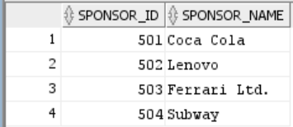

1. **Accomodation**

INSERT INTO Accomodation VALUES(601, 'Taj Hotel', 200);

INSERT INTO Accomodation VALUES(602, 'Radisson Blu', 300);

INSERT INTO Accomodation VALUES(603, 'Grand Hyatt', 250);

INSERT INTO Accomodation VALUES(604, 'Holiday Inn', 350);

INSERT INTO Accomodation VALUES(605, 'Leela Palace', 150);

SELECT * FROM Accomodation;

**Output:**

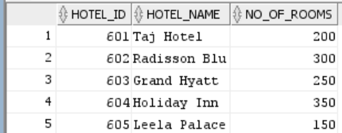

1. **Transport**

INSERT INTO Transport VALUES(701, 'Bus', 15, 601);

INSERT INTO Transport VALUES(702, 'Van', 10, 601);

INSERT INTO Transport VALUES(703, 'Car', 8, 602);

INSERT INTO Transport VALUES(704, 'Van', 10, 602);

INSERT INTO Transport VALUES(705, 'Bus', 20, 603);

INSERT INTO Transport VALUES(706, 'Car', 5, 604);

INSERT INTO Transport VALUES(707, 'Van', 12, 604);

INSERT INTO Transport VALUES(708, 'Car', 5, 605);

INSERT INTO Transport VALUES(709, 'Car', 8, 605);

SELECT * FROM Transport;

**Output:**

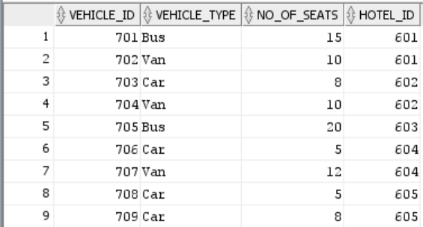

1. **Coach**

INSERT INTO Coach VALUES(401, 'Glen Mills', 602);

INSERT INTO Coach VALUES(402, 'Dennis Mitchell', 601);

INSERT INTO Coach VALUES(403, 'Rana Reider', 604);

INSERT INTO Coach VALUES(404, 'Kim Ji-hyun', 601);

INSERT INTO Coach VALUES(405, 'Shoji Sato', 605);

INSERT INTO Coach VALUES(406, 'Fernando Rivas', 603);

INSERT INTO Coach VALUES(407, 'Thomas Karsch', 602);

INSERT INTO Coach VALUES(408, 'Russell Mark', 604);

SELECT * FROM Coach;

**Output:**

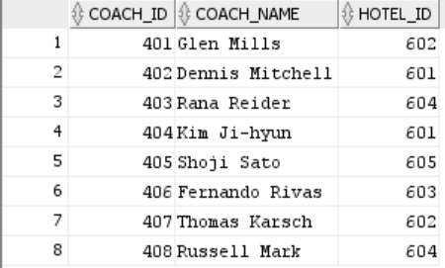

1. **Stadiums**

INSERT INTO Stadiums VALUES(801, 'Rio de Janeiro', 25000, 'Engenehao Stadium');

INSERT INTO Stadiums VALUES(802, 'Rio de Janeiro', 30000, 'Riocentro');

INSERT INTO Stadiums VALUES(803, 'Sao Paulo', 10000, 'Sambrodomo');

SELECT * FROM Stadiums;

**Output:**

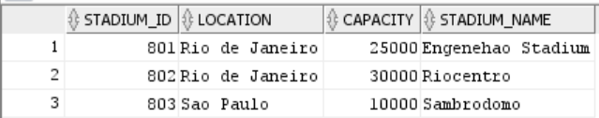

1. **Country**

INSERT INTO Country values(201, 'USA', 1, 32);

INSERT INTO Country values(202, 'Canada', 2, 23);

INSERT INTO Country values(203, 'Japan', 3, 17);

INSERT INTO Country values(204, 'Jamaica', 4, 8);

INSERT INTO Country values(205, 'South Africa', 5, 7);

INSERT INTO Country values(206, 'India', 6, 4);

INSERT INTO Country values(207, 'Spain', 7, 3);

SELECT * FROM Country;

**Output:**

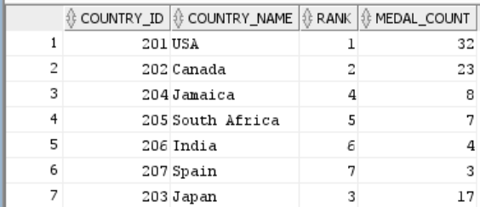

1. **Officials**

INSERT INTO Officials VALUES(901, 'Chris Beath', 5);

INSERT INTO Officials VALUES(902, 'Kate Jacewicz', 8);

INSERT INTO Officials VALUES(903, 'Ashley Beecham', 4);

SELECT * FROM Officials;

**Output:**

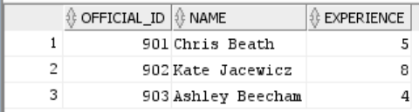

1. **Spectator**

INSERT INTO Spectator VALUES(1001, 'Camilla Beck', 605);

INSERT INTO Spectator VALUES(1002, 'Jeffrey Collins', 603);

INSERT INTO Spectator VALUES(1004, 'George Noble', 602);

INSERT INTO Spectator VALUES(1005, 'Rachel Poole', 604);

INSERT INTO Spectator VALUES(1006, 'Melody Hunter', 602);

INSERT INTO Spectator VALUES(1007, 'Kendrick Hayward', 601);

SELECT * FROM Spectator;

**Output:**

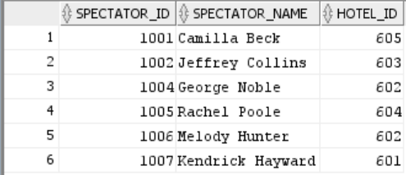

1. **Recreation**

INSERT INTO Recreation VALUES('Bar', 200);

INSERT INTO Recreation VALUES('Pool Table', 400);

INSERT INTO Recreation VALUES('Gaming', 100);

INSERT INTO Recreation VALUES('Spa', 600);

SELECT * FROM Recreation;

**Output:  
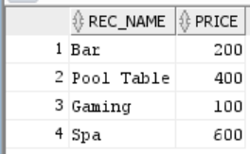**

1. **Event**

INSERT INTO Event VALUES(101, 'Men''s 100m Sprint', 'Track', 801);

INSERT INTO Event VALUES(102, 'Women''s Badminton', 'Sport', 802);

INSERT INTO Event VALUES(103, 'Women''s 25m Shooting', 'Sport', 803);

SELECT * FROM Event;

**Output:**

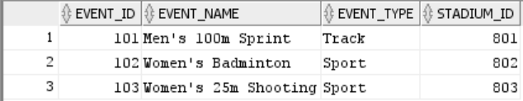

1. **Participants**

INSERT INTO Participants VALUES(301, 'Usain Bolt', 1, 204, 401, 602, 101);

INSERT INTO Participants VALUES(302, 'Justin Gatlin', 3, 201, 402, 601, 101);

INSERT INTO Participants VALUES(303, 'Andre De Grasse', 4, 202, 403, 604, 101);

INSERT INTO Participants VALUES(304, 'Yohan Blake', 6, 204, 401, 602, 101);

INSERT INTO Participants VALUES(305, 'P. V. Sindhu', 3, 206, 404, 601, 102);

INSERT INTO Participants VALUES(306, 'Nozomi Okuhara', 2, 203, 405, 605, 102);

INSERT INTO Participants VALUES(307, 'Carolina Marin', 5, 207, 406, 603, 102);

INSERT INTO Participants VALUES(308, 'Anna Kortozaki', 8, 205, 404, 601, 102);

INSERT INTO Participants VALUES(309, 'Monika Karsch', 1, 202, 407, 602, 103);

INSERT INTO Participants VALUES(310, 'Heidi Diethelm Gerber', 4, 207, 408, 604, 103);

SELECT * FROM Participants;

**Output:**

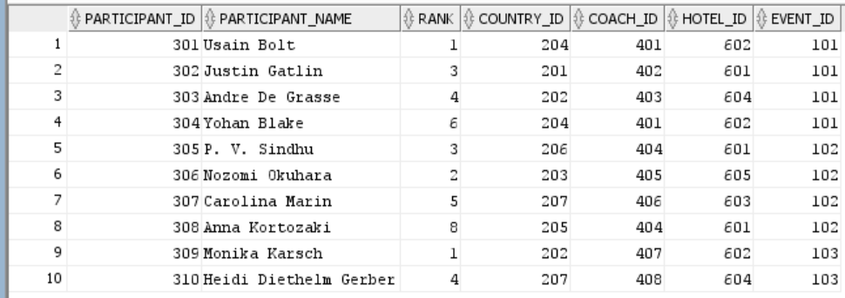

1. **Match**

INSERT INTO Match VALUES(1, 301, 302, 801, 901);

INSERT INTO Match VALUES(2, 303, 304, 801, 902);

INSERT INTO Match VALUES(3, 305, 306, 802, 903);

INSERT INTO Match VALUES(4, 307, 308, 802, 901);

INSERT INTO Match VALUES(5, 309, 310, 803, 902);

SELECT * FROM Match;

**Output:**

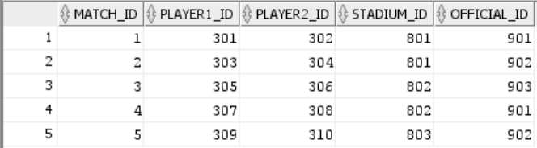

1. **Tickets**

INSERT INTO Tickets VALUES(1101, 2000, 1001, 1);

INSERT INTO Tickets VALUES(1102, 1200, 1001, 2);

INSERT INTO Tickets VALUES(1103, 3000, 1002, 3);

INSERT INTO Tickets VALUES(1104, 2500, 1004, 4);

INSERT INTO Tickets VALUES(1105, 1000, 1005, 5);

SELECT * FROM Tickets;

**Output:**

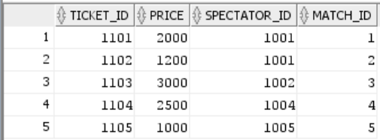

1. **Indulge**

INSERT INTO Indulge VALUES('Bar', 1001);

INSERT INTO Indulge VALUES('Gaming', 1004);

INSERT INTO Indulge VALUES('Pool Table', 1006);

INSERT INTO Indulge VALUES('Spa', 1007);

SELECT * FROM Indulge;

**Output:**

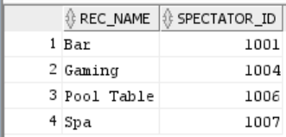

1. **Advertises**

INSERT INTO Advertises VALUES(501, 101);

INSERT INTO Advertises VALUES(502, 102);

INSERT INTO Advertises VALUES(503, 103);

INSERT INTO Advertises VALUES(504, 103);

SELECT * FROM Advertises;

**Output:**

